**VISVESVARAYA TECHNOLOGICAL UNIVERSITY**

**“JnanaSangama”, Belgaum -590014, Karnataka.**



**LAB REPORT**

**on**

**BIG DATA ANALYTICS**

**(20CS6PEBDA)**

***Submitted by***

**VIGHNESH CHANDRASHEKHAR**

**(1BM19CS182)**

***in partial fulfillment for the award of the degree of***

**BACHELOR OF ENGINEERING**

***in***

# COMPUTER SCIENCE AND ENGINEERING



# B.M.S. COLLEGE OF ENGINEERING

**(Autonomous Institution under VTU)**

**BENGALURU-560019**

**May-2022 to July-2022**

**B. M. S. College of Engineering,**

**Bull Temple Road, Bangalore 560019**

(Affiliated To Visvesvaraya Technological University, Belgaum)

## Department of Computer Science and Engineering



**CERTIFICATE**

This is to certify that the Lab work entitled “**BIG DATA ANALYTICS**” was carried out by **VIGHNESH CHANDRASHEKHAR (1BM19CS182),** who is bonafide student of **B. M. S. College of Engineering.** It is in partial fulfillment for the award of **Bachelor of Engineering in Computer Science and Engineering** of the Visvesvaraya Technological University, Belgaum during the year 2022. The Lab report has been approved as it satisfies the academic requirements in respect of the course **BIG DATA ANALYTICS (20CS6PEBDA)** work prescribed for the said degree.

|  |  |
| --- | --- |
| Name of the Lab-In charge | **DR. PALLAVI G.B.** |
| Designation | Assistant Professor |
| Department of CSE | Department of CSE |
| BMSCE, Bengaluru | BMSCE, Bengaluru |

`

# Index Sheet

|  |  |  |
| --- | --- | --- |
| **Sl.**  **No.** | **Experiment Title** | **Page No.** |
| **1** | **Cassandra Lab Program 1: - Student Database** | **5** |
| **2** | **Cassandra Lab Program 2: - Library Database** | **7** |
| **3** | **MongoDB- CRUD Demonstration** | **12** |
| **4** | **Hadoop Installation** | **28** |
| **5** | **Hadoop Commands** | **29** |
| **6** | **Hadoop Programs: Word Count** | **31** |
| **7** | **Hadoop Programs: Top N** | **39** |
| **8** | **Hadoop Programs: Average Temperature** | **46** |
| **9** | **Hadoop Programs: Join** | **52** |
| **10** | **Scala Programs: Word Count** | **56** |
| **11** | **Scala Programs: Word Count greater than 4** | **58** |

**Course Outcome**

|  |  |
| --- | --- |
| CO1 | Apply the concept of NoSQL, Hadoop or Spark for a given task |
| CO2 | Analyze the Big Data and obtain insight using data analytics mechanisms. |
| CO3 | Design and implement Big data applications by applying NoSQL, Hadoop or Spark |

# Cassandra Lab Program 1: -

Perform the following DB operations using Cassandra.

1. Create a key space by name Employee

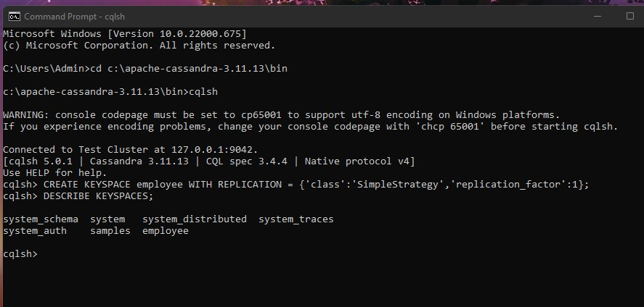

1. Create a column family by name Employee-Info with attributes Emp_Id Primary Key, Emp_Name,

Designation, Date_of_Joining, Salary, Dept_Name

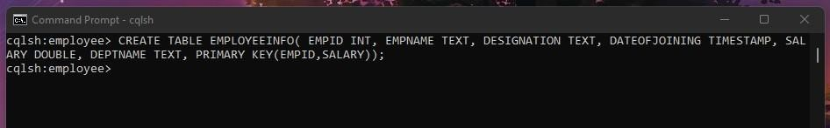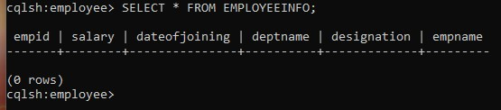

1. Insert the values into the table in batch

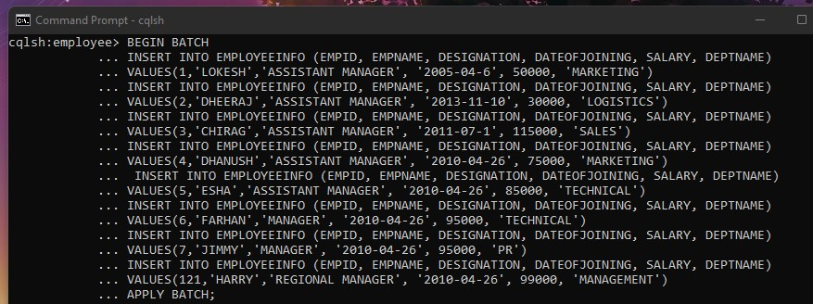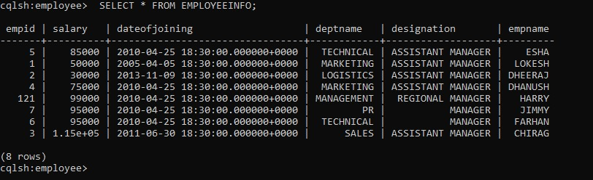

1. Update Employee name and Department of Emp-Id 121

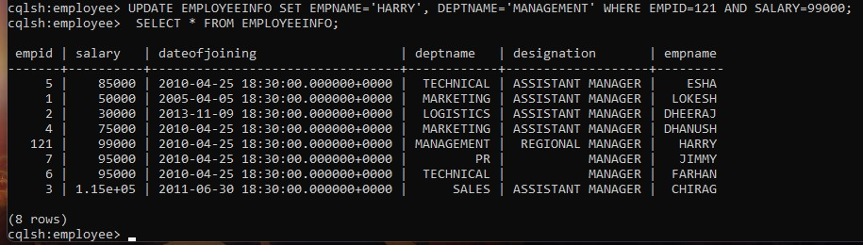

1. Sort the details of Employee records based on salary (Note:- cql>PAGING OFF)

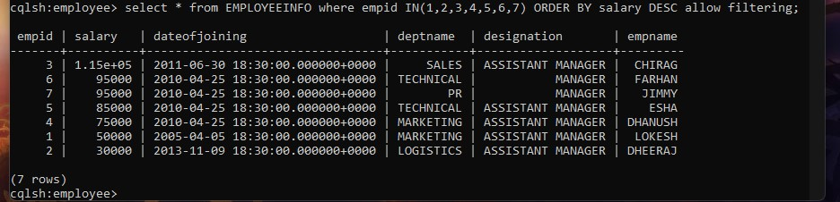

1. Alter the schema of the table Employee_Info to add a column Projects which stores a set of Projects done by the corresponding Employee.

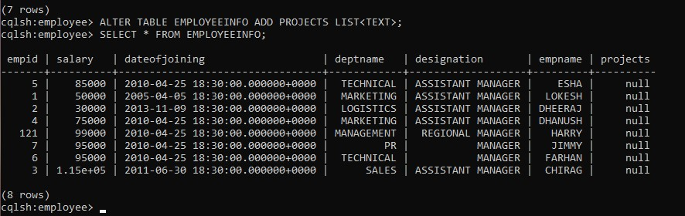

1. Update the altered table to add project names.

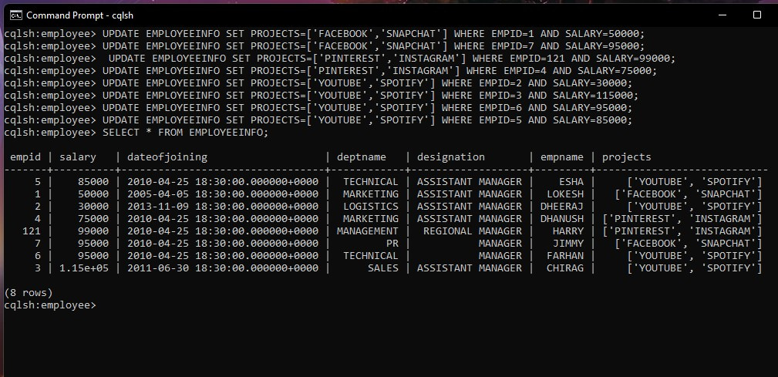

1. Create a TTL of 15 seconds to display the values of Employees.

//BEFORE 15 seconds

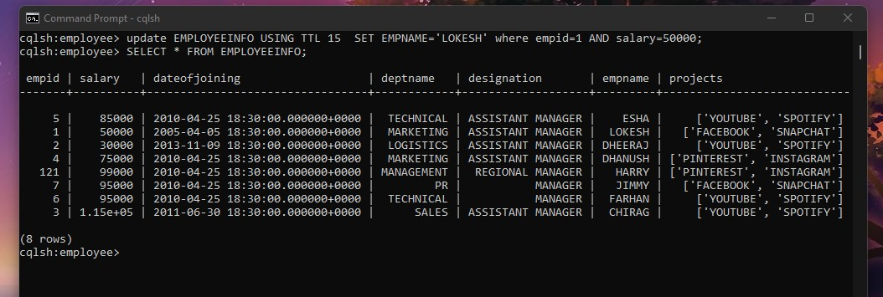

# Cassandra Lab Program 2: -

Perform the following DB operations using Cassandra.

1.Create a key space by name Library

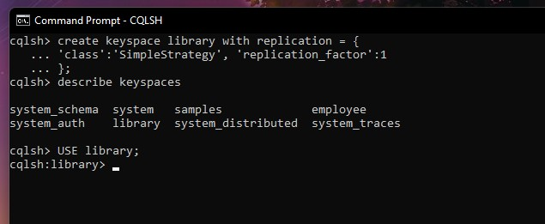

1. Create a column family by name Library-Info with attributes Stud_Id Primary Key,

Counter_value of type Counter,

Stud_Name, Book-Name, Book-Id, Date_of_issue

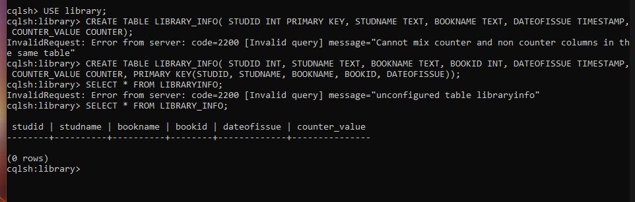

1. Insert the values into the table in batch

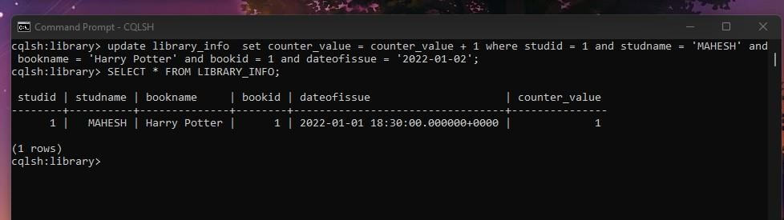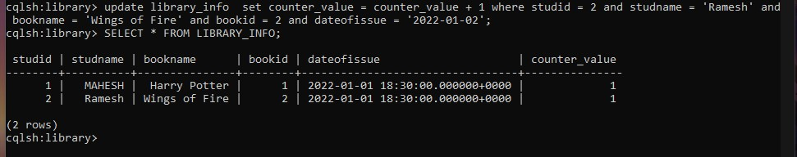

4. Display the details of the table created and increase the value of the counter

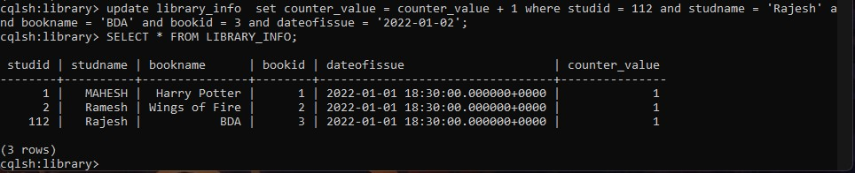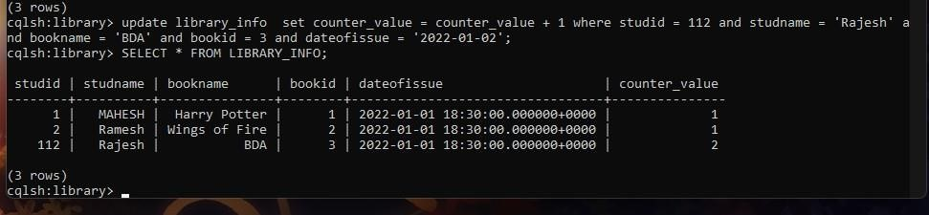

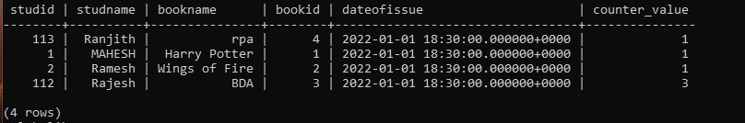

5. Write a query to show that a student with id 112 has taken a book “BDA” 3 times.

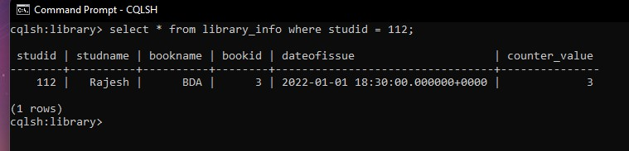

6. Export the created column to a csv file

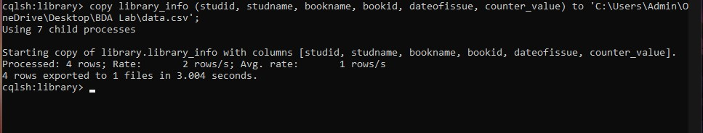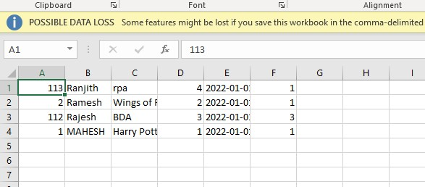

7. Import a given csv dataset from local file system into Cassandra column family

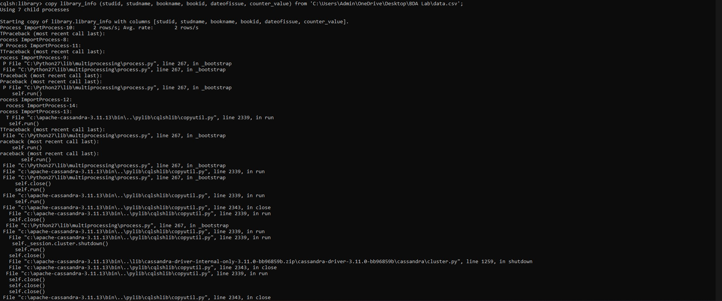

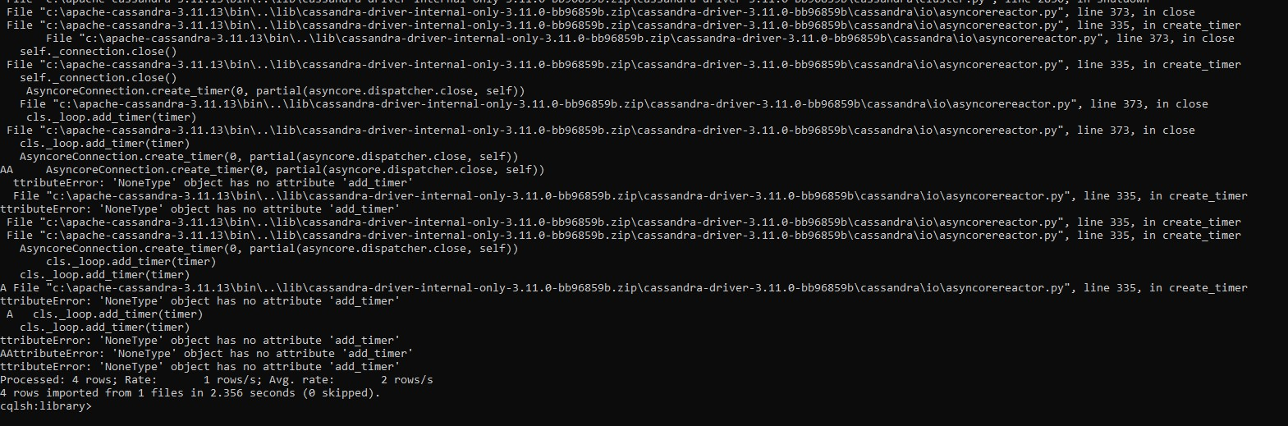

# MongoDB Lab Program 1 (CRUD Demonstration): -

Execute the queries and upload a document with output.

1. CREATE DATABASE IN MONGODB. use myDB; db; (Confirm the existence of your database) show dbs; (To list all databases)

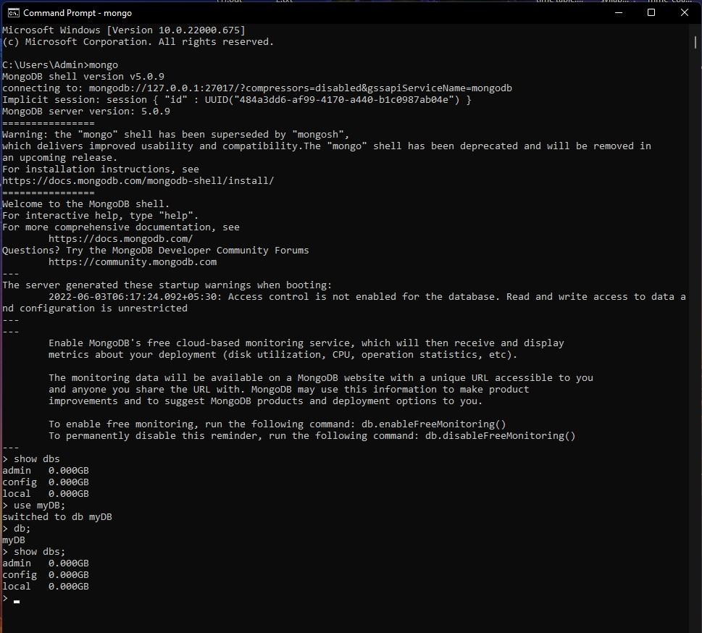

1. CRUD (CREATE, READ, UPDATE, DELETE) OPERATIONS
2. To create a collection by the name “Student”. Let us take a look at the collection list prior to the creation of the new collection “Student”.

db.createCollection(“Student”); =&gt; sql equivalent CREATE TABLE STUDENT(…);

1. To drop a collection by the name “Student”.

db.Student.drop();

1. Create a collection by the name “Students” and store the following data in it.

db.Student.insert({_id:1,StudName:&quot;MichelleJacintha&quot;,Grade:&quot;VII&quot;,Hobbies:&quot;Int ernetS

urfing&quot;});

1. Insert the document for “AryanDavid” in to the Students collection only if it does not already exist in the collection. However, if it is already present in the collection, then update the document with new values. (Update his Hobbies from “Skating” to “Chess”. ) Use “Update else insert” (if there is an existing document, it will attempt to update it, if there is no existing document then it will insert it).

db.Student.update({_id:3,StudName:&quot;AryanDavid&quot;,Grade:&quot;VII&quot;},{$set:{Hobbies:&quo t;Skatin

g&quot;}},{upsert:true});

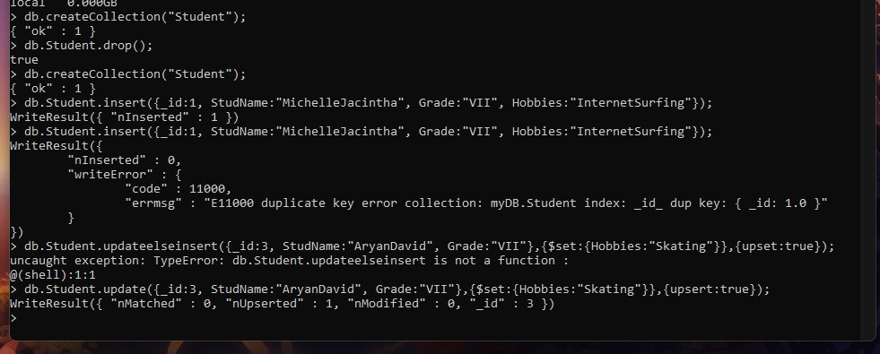

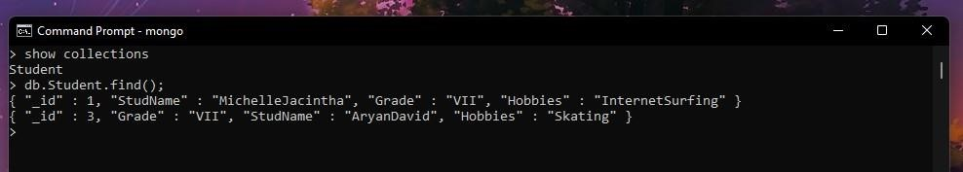

1. FIND METHOD
2. To search for documents from the “Students” collection based on certain search criteria.

db.Student.find({StudName:&quot;Aryan David&quot;});

({cond..},{columns.. column:1, columnname:0} )



1. To display only the StudName and Grade from all the documents of the Students collection. The identifier_id should be suppressed and NOT displayed. db.Student.find({},{StudName:1,Grade:1,_id:0});

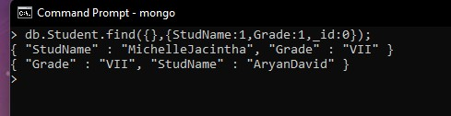

1. To find those documents where the Grade is set to ‘VII’ db.Student.find({Grade:{$eq:&#39;VII&#39;}}).pretty();

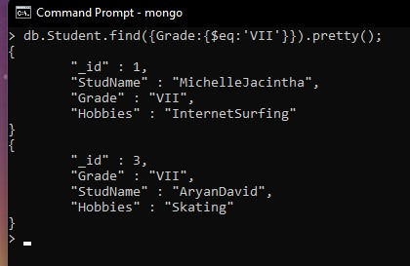

1. To find those documents from the Students collection where the Hobbies is set to either ‘Chess’ or is set to ‘Skating’.

db.Student.find({Hobbies :{ $in: [&#39;Chess&#39;,&#39;Skating&#39;]}}).pretty ();

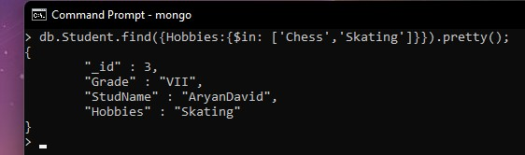

1. To find documents from the Students collection where the StudName begins with “M”. db.Student.find({StudName:/^M/}).pretty();

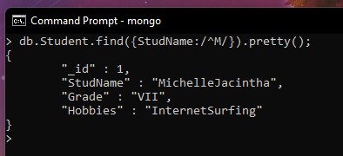

1. To find documents from the Students collection where the StudNamehas an “e” in any position. db.Student.find({StudName:/e/}).pretty();

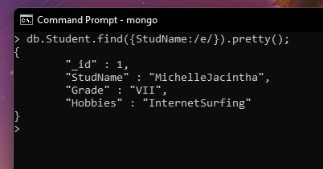

1. To find the number of documents in the Students collection. db.Student.count();

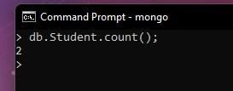

1. To sort the documents from the Students collection in the descending order of StudName.

db.Student.find().sort({StudName:-1}).pretty();

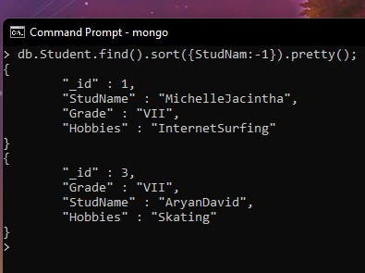

1. Import data from a CSV file

Given a CSV file “sample.txt” in the D:drive, import the file into the MongoDB collection, “SampleJSON”. The collection is in the database “test”.

mongoimport --db Student --collection airlines --type csv –headerline --file

/home/hduser/Desktop/airline.csv

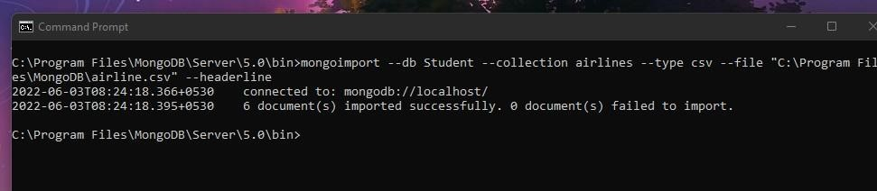

1. Export data to a CSV file

This command used at the command prompt exports MongoDB JSON documents from

“Customers” collection in the “test” database into a CSV file “Output.txt” in the D:drive.

mongoexport --host localhost --db Student --collection airlines --csv --out

/home/hduser/Desktop/output.txt –fields “Year”,”Quarter”

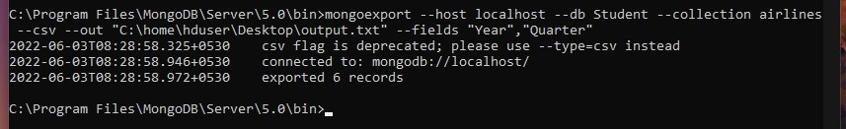

1. Save Method :

Save() method will insert a new document, if the document with the _id does not exist. If it exists it will replace the exisiting document. db.Students.save({StudName:”Vamsi”, Grade:”VI”})

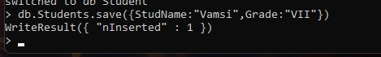

1. Add a new field to existing Document: db.Students.update({_id:4},{$set:{Location:”Network”}})

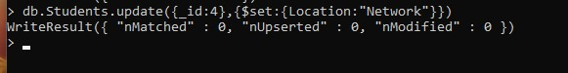

1. Remove the field in an existing Document

db.Students.update({_id:4},{$unset:{Location:”Network”}})

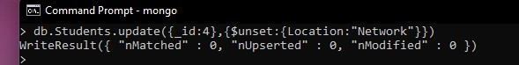

1. Finding Document based on search criteria suppressing few fields db.Student.find({_id:1},{StudName:1,Grade:1,_id:0}); To find those documents where the Grade is not set to ‘VII’ db.Student.find({Grade:{$ne:&#39;VII&#39;}}).pretty();

To find documents from the Students collection where the StudName ends with s. db.Student.find({StudName:/s$/}).pretty();

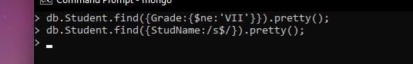

1. to set a particular field value to NULL

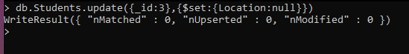

X Count the number of documents in Student Collections



1. Count the number of documents in Student Collections with grade :VII db.Students.count({Grade:”VII”}) retrieve first 3 documents

db.Students.find({Grade:”VII”}).limit(3).pretty(); Sort the document in Ascending order db.Students.find().sort({StudName:1}).pretty(); Note: for desending order : db.Students.find().sort({StudName:-1}).pretty(); to Skip the 1 st two documents from the Students Collections db.Students.find().skip(2).pretty()

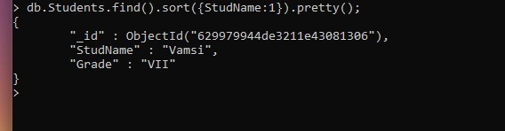

1. Create a collection by name “food” and add to each document add a “fruits” array db.food.insert( { _id:1, fruits:[&#39;grapes&#39;,&#39;mango&#39;,&#39;apple&#39;] } ) db.food.insert( { _id:2, fruits:[&#39;grapes&#39;,&#39;mango&#39;,&#39;cherry&#39;] } ) db.food.insert( { _id:3, fruits:[&#39;banana&#39;,&#39;mango&#39;] } )

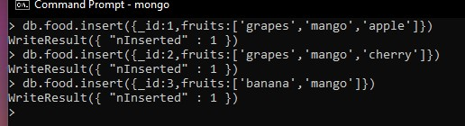

To find those documents from the “food” collection which has the “fruits array” constitute of “grapes”, “mango” and “apple”.

db.food.find ( {fruits: [&#39;grapes&#39;,&#39;mango&#39;,&#39;apple&#39;] } ). pretty().



To find in “fruits” array having “mango” in the first index position.

db.food.find ( {&#39;fruits.1&#39;:&#39;grapes&#39;} )



To find those documents from the “food” collection where the size of the array is two. db.food.find ( {“fruits”: {$size:2}} )

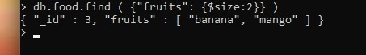

To find the document with a particular id and display the first two elements from the array “fruits”

db.food.find({_id:1},{“fruits”:{$slice:2}})



To find all the documets from the food collection which have elements mango and grapes in the array “fruits”

db.food.find({fruits:{$all:[“mango”,”grapes”]}})

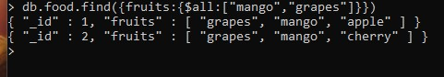

update on Array: using particular id replace the element present in the 1 st index position of the fruits array with apple db.food.update({_id:3},{$set:{&#39;fruits.1&#39;:&#39;apple&#39;}}) insert new key value pairs in the fruits array

db.food.update({_id:2},{$push:{price:{grapes:80,mango:200,cherry:100}}})

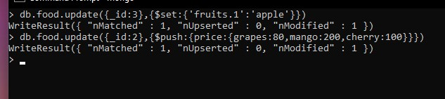

Note: perform query operations using - pop, addToSet, pullAll and pull

XII. Aggregate Function :

Create a collection Customers with fields custID, AcctBal, AcctType.

Now group on “custID” and compute the sum of “AccBal”. db.Customers.aggregate ( {$group : { _id : “$custID”,TotAccBal : {$sum:”$AccBal”} } } ); match on AcctType:”S” then group on “CustID” and compute the sum of “AccBal”. db.Customers.aggregate ( {$match:{AcctType:”S”}},{$group : { _id : “$custID”,TotAccBal :

{$sum:”$AccBal”} } } ); match on AcctType:”S” then group on “CustID” and compute the sum of “AccBal” and total balance greater than 1200.

db.Customers.aggregate ( {$match:{AcctType:”S”}},{$group : { _id : “$custID”,TotAccBal :

{$sum:”$AccBal”} } }, {$match:{TotAccBal:{$gt:1200}}});

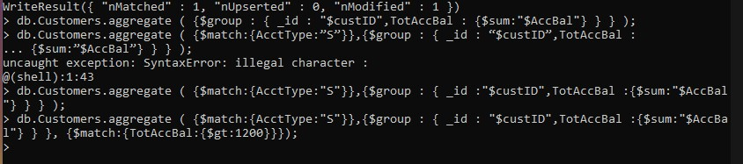

# MongoDB Lab Program 2 (CRUD Demonstration): -

1) Using MongoDB

i) Create a database for Students and Create a Student Collection (_id,Name, USN, Semester, Dept_Name, CGPA, Hobbies(Set)). ii) Insert required documents to the collection.

1. First Filter on “Dept_Name:CSE” and then group it on “Semester” and

compute the Average CPGA for that semester and flter those documents where the “Avg_CPGA” is greater than 7.5.

1. Command used to export MongoDB JSON documents from “Student” Collection into the

“Students” database into a CSV fle “Output.txt”.



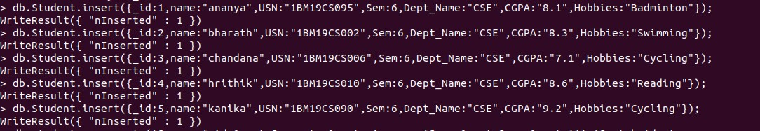

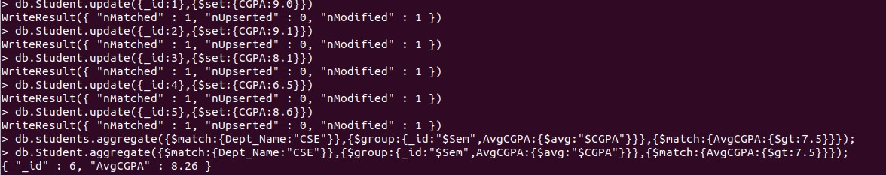



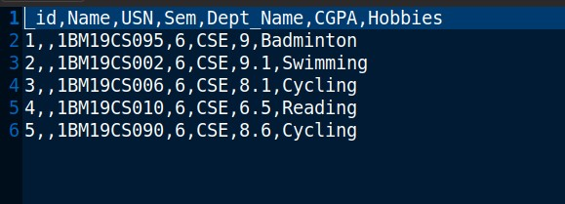

2) Create a mongodb collection Bank. Demonstrate the following by choosing felds of your choice.

1. Insert three documents
2. Use Arrays(Use Pull and Pop operation)
3. Use Index
4. Use Cursors

1. Updation

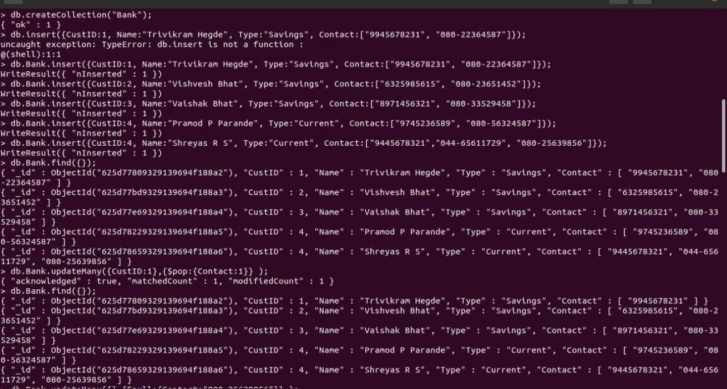

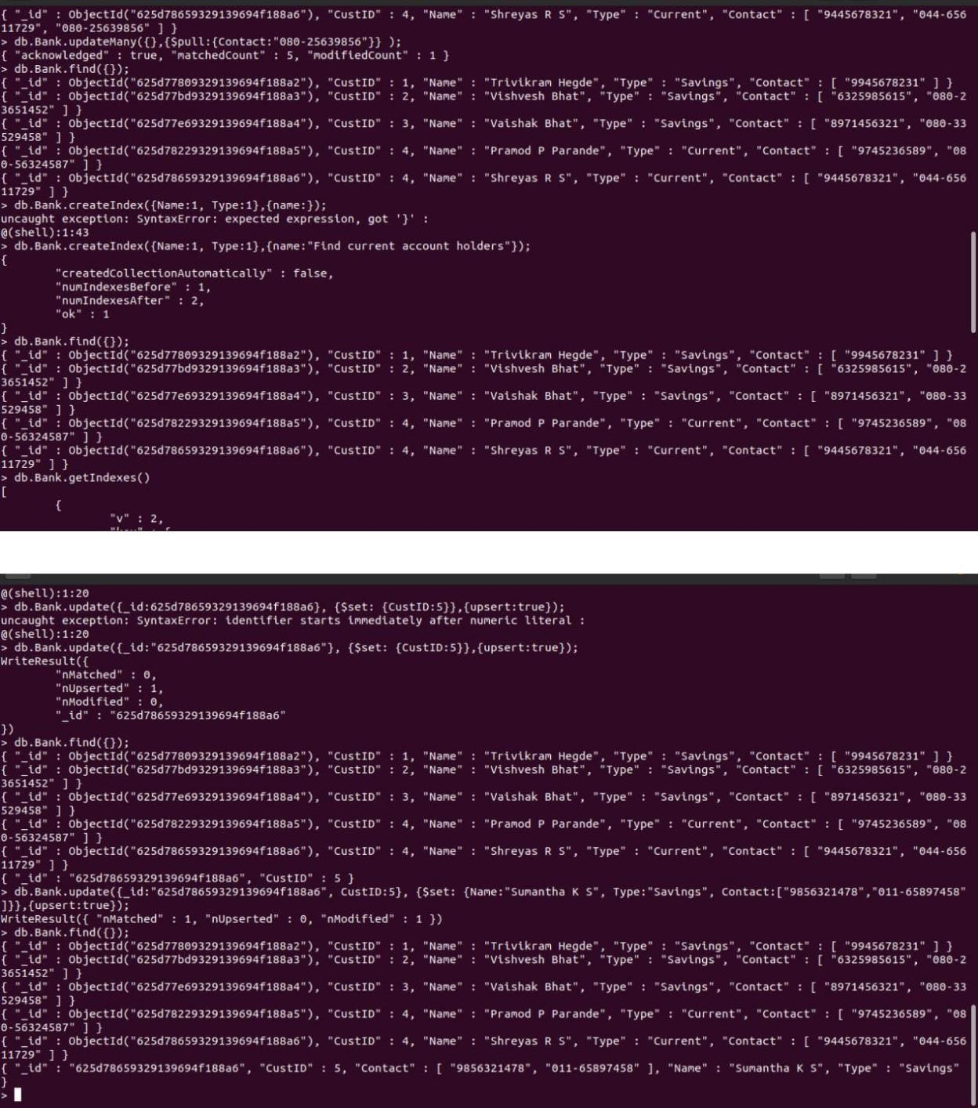

1) Using MongoDB,

i) Create a database for Faculty and Create a Faculty Collection(Faculty_id, Name, Designation ,Department, Age, Salary, Specialization(Set)). ii) Insert required documents to the collection.

iii) First Filter on “Dept_Name:MECH” and then group it on “Designation” and compute the Average Salary for that Designation and flter those documents where the “Avg_Sal” is greater than 650000. iv) Demonstrate usage of import and export commands

Write MongoDB queries for the following: 1) To display only the product name from all the documents of the product collection.

1. To display only the Product ID, ExpiryDate as well as the quantity from the document of the product collection where the _id column is 1.
2. To fnd those documents where the price is not set to 15000.
3. To fnd those documents from the Product collection where the quantity is set to 9 and the product name is set to ‘monitor’. 5) To fnd documents from the Product collection where the Product name ends in ‘d’.

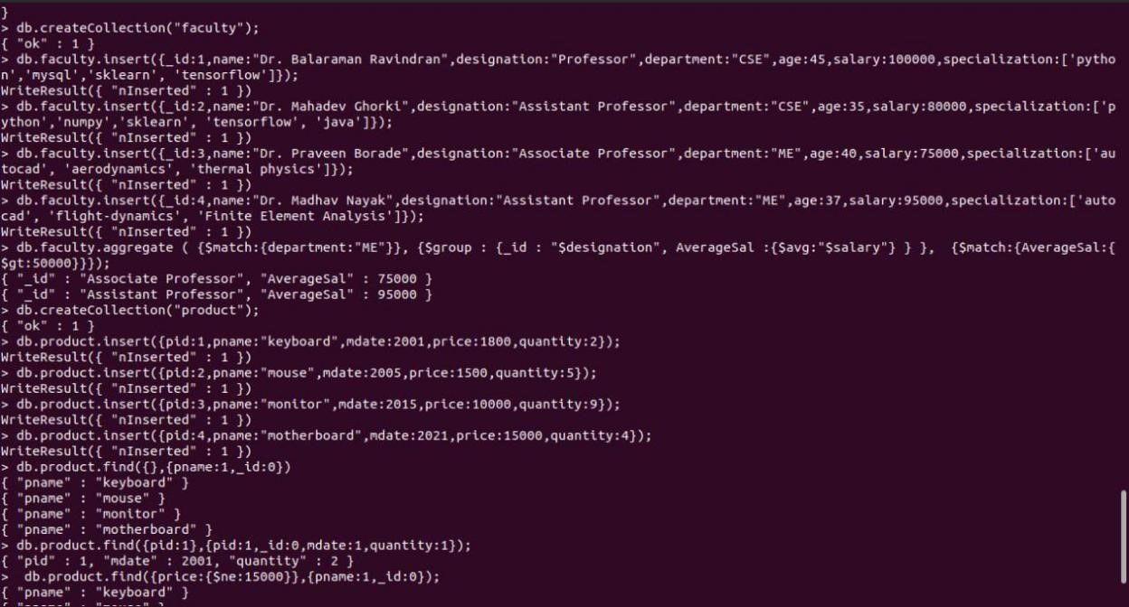

3)Create a mongodb collection Hospital. Demonstrate the following by choosing felds of choice.

1

. Insert three documents

2

. Use Arrays(Use Pull and Pop operation)

3

. Use Index

4

. Use Cursors

Updation

5

.

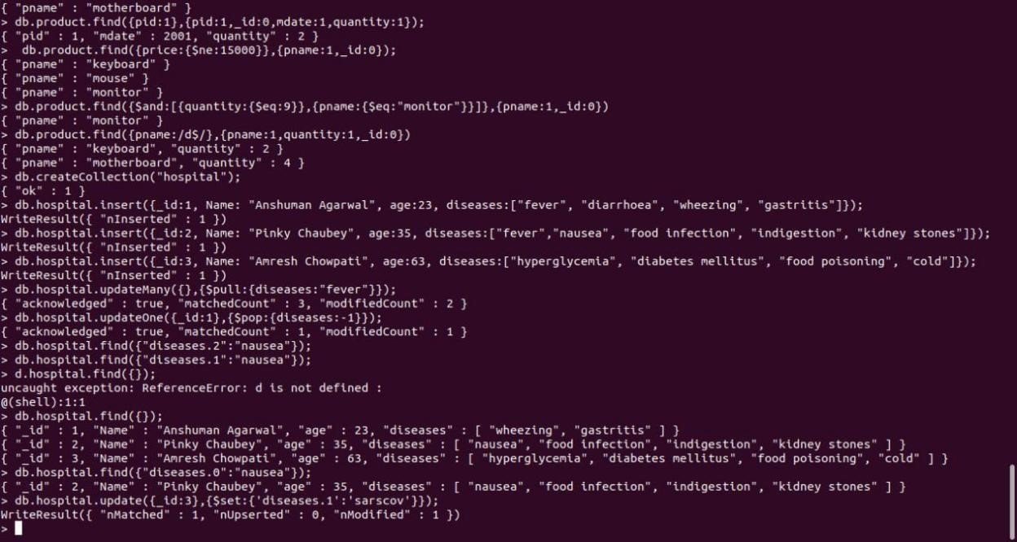

Hadoop Commands

hdusersbmsce-OptiPlus-3000:-$ sudo su hduser [sudo] password for hduser:

hdusersbmsce-OptiPlus-3000: $ start-all.sh

This script is Deprecated. Instead use start-dfs.sh and start-yarn.sh

22/06/06 14:43:45 WARN util.NativeCodeLoader: Unable to load native-hadoop

Library for your platform... using builtin-java classes where applicable Starting namenodes on [localhost] localhost: nanenade running as process 3396. Stop it first. localhost: datanode running as process 3564, Stop it first.

starting secondary nanenodes [0.0.0.0)

0.0.0.0: secondarynamenode running as process 3773. Stop it first. O22/06/06 14:43:47 WARN uttt.NativeCodeLoader: Unable to load native-hadoop library for your starting yarn daemons resource process 3932. Stop it first.

Localhost: running as process 4255. stop it first.

6003 Jps

3932 ResourceManager

3773 SecondaryNameNode 4255 NodeManager

hdusersbmsce-OptiPlus-3060:-$ hdfs dfs -mkdir /khushil hdusersbmsce-OptiPlus-3060: $ hdfs dfs -ls /

22/06/06 14:45:30 WARN util.NativeCodeLoader: Unable to load native-hadoop library for your platform... using builtin-java classes where applicable Found 19 itens

drwxr-xr-x hduser supergroup 02022-06-06 11:44 /AAA drwxr-xr-x -hduser supergroup 2022-06-03 12:17 /Army drwxr-xr-x hduser supergroup 02022-06-06 11:40 /Avnit drwxr-xr-x -hduser supergroup 02022-05-31 10:44 /88 drwxr-xr-x -hduser supergroup 02022-06-01 15:03 /Cath drwxr-xr-x -hduser supergroup drwxr-xr-x hduser supergroup drwxr-xr-x -hduser supergroup drwxr-xr-x -hduser supergroup drwxr-xr-x -hduser supergroup drwxr-xr-x -hduser supergroup drwxr-xr-x -hduser supergroup drwxr-xr-x -hduser supergroup drwxr-xr-x -hduser supergroup drwxr-xr-x - hduser supergroup drwxr-xr-x -hduser supergroup

82022-06-04 10:06 /FFF

02022-06-06 14:40 /Kmrv

02022-06-06 14:44 /Khushil

02022-06-01 15:03 /Neha

02022-06-04 09:54 /WC.txt

0 2022-06-04 09:54 /welcone.txt

02022-06-06 11:36 /abc

62022-06-03 12:13 /akash

0 2022-06-03 15:12 /darshan

0 2022-06-04 09:31 /ghh 8 2022-06-06 11:45 /hello drwxr-xr-x -hduser supergroup 62022-06-04 09:35 /rahul drwxr-xr-x -hduser supergroup 02022-06-03 12:11 /shre drwxr-xr-x .hduser supergroup 02022-06-03 12:41 /shreshtha

hdusersbmsce-OptiPlus-3060:-$ hdfs dfs put /home/hduser/Desktop/6b.txt

/Khushil/WC.txt

22/05/06 14:46:40 WARN util.NativeCodeLoader: Unable to load native-hadoop library for your platform... using butltin-java classes where applicable hduserabesce-OptiPlex-3060:-$ hdfs dfs cat /Khushil/WC.txt

22/06/06 14:47:00 WARN util.NativeCodeLoader: Unable to load native-hadoop library for your platform... using builtin-java classes where applicable hello fron of

hdusersbmsce-OptiPlus-3040:-$ hdfs dfs-get /Khushil/WC.txt

/home/hduser/Downloads/newic.txt

22/05/06 14:51:43 WARN util.NativeCodeLoader: Unable to load nattve-hadoop library for your platform... using builtin-java classes where applicable hdusersbmsce-OptiPlus-3066:-$ cd Downloads hdusersbmsce-OptiPlus-3060:-/Downloads$ cat newwMC.Ext hello from 6E

hdusersbmsce-OptiPlus-3060:-$ hdfs dfs -1s /Khushil/

22/06/06 14:54:04 WARN util.NativeCodeLoader: Unable to load native-hadoop

Library for your platform... using builtin java classes where applicable

Found 2 itens

-rw-r--r-- 1 hduser supergroup

23 2822-06-06 14:46 /Khushil/MC.txt

1 hduser supergroup

23 2022-06-06 14:58 /Khushil/newwc.txt

hdusersbmsce-OptiPlus-3060:-5 hdfs drs -getmerge /Khushil/wc.txt

/Khushil/newwc.txt /bone/hduser/Desktop/newmerge.txt

22/06/06 14:55:18 NARN util.NativeCodeLoader: Unable to load nattve-hadoop library for your platform... using butitin-Java classes where applicable hduserabesce-OptiPlex-3060:~$ cd Desktop hduser@besce-OptiPlex-3060:-/Desktops cat newmerge.txt hello from 68

D B

hello from 68

D B

hdusersbmsce-OptiPlus-3060:-/Desktops hadoop fs getfacl /Khushil/ 22/06/06 14:56:24 WARN util.NativeCodeLoader: Unable to load native hadoop library for your platform... using builtin java classes where applicable

# file: /Khushil

# owner: hduser # group: supergroup user::rwx group::r-x other::r-x

hdusersbmsce-OptiPlus-3060:-/Desktop5 hdfs dfs copyToLocal /Khushil/HC.txt

/home/hduser/Desktop

22/05/06 14:58:09 WARN util.NativeCodeLoader: Unable to load native-hadoop Library for your platform... using butltin-java classes where applicable hdusersbmsce-OptiPlus-3000:-/Desktop5 cat MC.txt hello fron 68

hdusersbmsce-OptiPlus-3060:-/Desktops hdfs dfs -cat /Khushil/MC.txt 22/06/06 14:58:59 WARN util.NativeCodeLoader: Unable to load native-hadoop Library for your platform... ustng bulltin-Java classes where applicable hello from GB B

hdusersbmsce-OptiPlus-3060:-/Desktop5 hadoop fs - /Khushil /FFF 22/06/06 14:59:46 WARN util.NativeCodeLoader: Unable to load native-hadoop Library for your platform... using builtin-java classes where applicable hduseransce- OptiPlex-3060:-/Desktops hadoop fs-Ls /FFF 22/05/06 15:00:00 WARN util.NativeCodeLoader: Unable to load native-hadoop library for your platform... using butltin-java classes where applicable Found 2 itens drwxr- xr-x -hduser supergroup TWEE 1 hduser supergroup 02022-05-06 14:50

/FFF/Khushil 17 2022-05-04 10:06 /FFF/MC.txt

hdusersbmsce-OptiPlus-3060:-/Desktops hadoop fs cp /FFF/ /LLL

22/06/06 15:09:34 WARN util.NativeCodeLoader: Unable to load native hadoop library for your platform... using butltin-java classes where applicable hdusersbmsce-OptiPlus-3060:-/Desktops hadoop fs -Ls /LLL

22/06/06 15:10:07 WARN util.NativeCodeLoader: Unable to load native-hadoop library for your platform... using builtin-java classes where applicable Found 2 1tens

drwxr-xr-x -hduser supergroup hdusersbmsce-OptiPlus-3000:-/Desktops

02022-06-06 15:09 /LLL/KHUSHIL

17 2022-00-00 15:09 /LLL/MC.txt

Hadoop Programs

1) Word Count

WCMapper Java Class file.

// Importing libraries import java.io.IOException; import org.apache.hadoop.io.IntWritable; import org.apache.hadoop.io.LongWritable; import org.apache.hadoop.io.Text;

import org.apache.hadoop.mapred.MapReduceBase; import org.apache.hadoop.mapred.Mapper; import org.apache.hadoop.mapred.OutputCollector; import org.apache.hadoop.mapred.Reporter;

public class WCMapper extends MapReduceBase implements

Mapper<LongWritable,

Text, Text, IntWritable> {

// Map function

public void map(LongWritable key, Text value, OutputCollector<Text, IntWritable> output, Reporter rep) throws IOException

{

String line = value.toString();

// Splitting the line on spaces for (String word : line.split(" "))

{ if (word.length() > 0)

{ output.collect(new Text(word), new IntWritable(1));

} } } }

Reducer Code

// Importing libraries import java.io.IOException; import java.util.Iterator; import org.apache.hadoop.io.IntWritable; import org.apache.hadoop.io.Text; import org.apache.hadoop.mapred.MapReduceBase; import org.apache.hadoop.mapred.OutputCollector; import org.apache.hadoop.mapred.Reducer; import org.apache.hadoop.mapred.Reporter;

public class WCReducer extends MapReduceBase implements Reducer<Text, IntWritable, Text, IntWritable> {

// Reduce function

public void reduce(Text key, Iterator<IntWritable> value,

OutputCollector<Text, IntWritable> output,

Reporter rep) throws IOException

{ int count = 0;

// Counting the frequency of each words while (value.hasNext())

{

IntWritable i = value.next(); count += i.get();

}

output.collect(key, new IntWritable(count)); }

}

Driver Code:

// Importing libraries import java.io.IOException; import org.apache.hadoop.conf.Configured; import org.apache.hadoop.fs.Path; import org.apache.hadoop.io.IntWritable; import org.apache.hadoop.io.Text; import org.apache.hadoop.mapred.FileInputFormat; import org.apache.hadoop.mapred.FileOutputFormat; import org.apache.hadoop.mapred.JobClient; import org.apache.hadoop.mapred.JobConf; import org.apache.hadoop.util.Tool; import org.apache.hadoop.util.ToolRunner;

public class WCDriver extends Configured implements Tool {

public int run(String args[]) throws IOException

{ if (args.length < 2)

{

System.out.println("Please give valid inputs"); return -1;

}

JobConf conf = new JobConf(WCDriver.class);

FileInputFormat.setInputPaths(conf, new Path(args[0])); FileOutputFormat.setOutputPath(conf, new Path(args[1]));

conf.setMapperClass(WCMapper.class); conf.setReducerClass(WCReducer.class); conf.setMapOutputKeyClass(Text.class); conf.setMapOutputValueClass(IntWritable.class); conf.setOutputKeyClass(Text.class); conf.setOutputValueClass(IntWritable.class);

JobClient.runJob(conf); return 0;

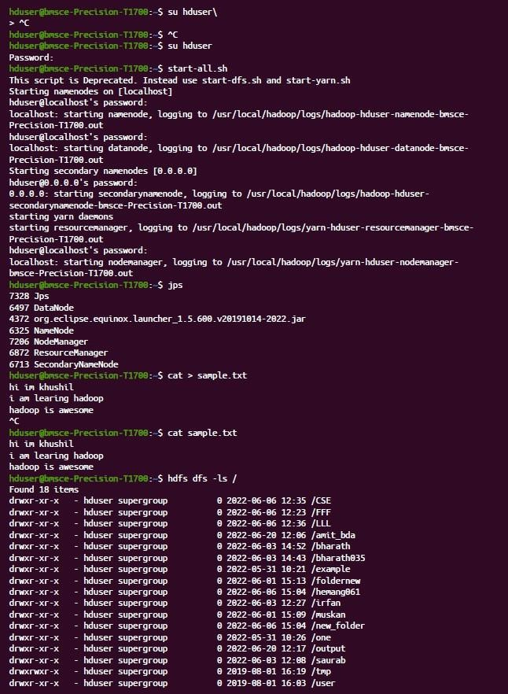}

// Main Method

public static void main(String args[]) throws Exception

{ int exitCode = ToolRunner.run(new WCDriver(), args);

System.out.println(exitCode);

}

}

Output :

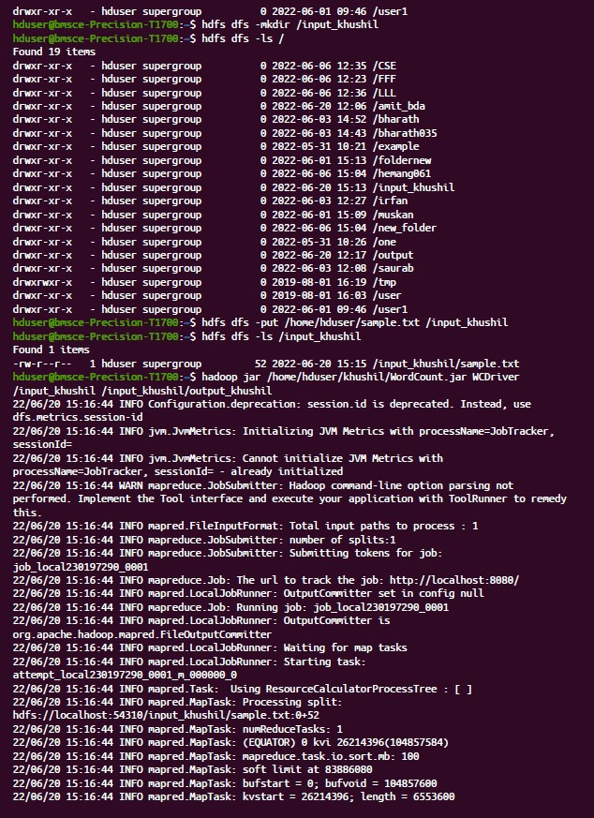

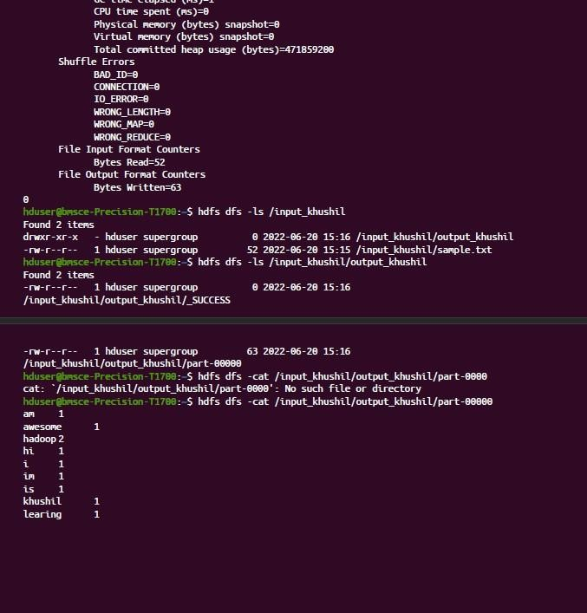

2) Top N

Driver-TopN.class **package** samples.topn;

**import** java.io.IOException; **import** java.util.StringTokenizer; **import** org.apache.hadoop.conf.Configuration; **import** org.apache.hadoop.fs.Path; **import** org.apache.hadoop.io.IntWritable; **import** org.apache.hadoop.io.Text; **import** org.apache.hadoop.mapreduce.Job; **import** org.apache.hadoop.mapreduce.Mapper;

**import** org.apache.hadoop.mapreduce.lib.input.FileInputFormat; **import**

org.apache.hadoop.mapreduce.lib.output.FileOutputFormat; **import** org.apache.hadoop.util.GenericOptionsParser;

**public class** TopN { **public static void** main(String[] args) **throws** Exception {

Configuration conf = **new** Configuration();

String[] otherArgs = (**new** GenericOptionsParser(conf, args)).getRemainingArgs(); **if** (otherArgs.length != 2) {

System.err.println("Usage: TopN <in> <out>"); System.exit(2);

}

Job job = Job.getInstance(conf); job.setJobName("Top N"); job.setJarByClass(TopN.**class**); job.setMapperClass(TopNMapper.**class**); job.setReducerClass(TopNReducer.**class**); job.setOutputKeyClass(Text.**class**); job.setOutputValueClass(IntWritable.**class**);

FileInputFormat.addInputPath(job, **new** Path(otherArgs[0]));

FileOutputFormat.setOutputPath(job, **new**

Path(otherArgs[1]));

System.exit(job.waitForCompletion(**true**) ? 0 : 1); }

**public static class** TopNMapper **extends** Mapper<Object, Text,

Text, IntWritable> { **private static final** IntWritable one = **new** IntWritable(1);

**private** Text word = **new** Text();

**private** String tokens = "[_|$#<>\\^=\\[\\]\\*/\\\\,;,.\\- :()?!\"']";

**public void** map(Object key, Text value, Mapper<Object,

Text, Text, IntWritable>.Context context) **throws** IOException,

InterruptedException {

String cleanLine = value.toString().toLowerCase().replaceAll(**this**.tokens, " "); StringTokenizer itr = **new** StringTokenizer(cleanLine); **while** (itr.hasMoreTokens()) { **this**.word.set(itr.nextToken().trim()); context.write(**this**.word, one);

}

}

}

}

TopNCombiner.class **package** samples.topn;

**import** java.io.IOException;

**import** org.apache.hadoop.io.IntWritable; **import** org.apache.hadoop.io.Text; **import** org.apache.hadoop.mapreduce.Reducer;

**public class** TopNCombiner **extends** Reducer<Text, IntWritable,

Text, IntWritable> { **public void** reduce(Text key, Iterable<IntWritable> values, Reducer<Text, IntWritable, Text, IntWritable>.Context context) **throws** IOException, InterruptedException { **int** sum = 0;

**for** (IntWritable val : values) sum += val.get();

context.write(key, **new** IntWritable(sum)); }

}

TopNMapper.class **package** samples.topn;

**import** java.io.IOException; **import** java.util.StringTokenizer; **import** org.apache.hadoop.io.IntWritable; **import** org.apache.hadoop.io.Text; **import** org.apache.hadoop.mapreduce.Mapper;

**public class** TopNMapper **extends** Mapper<Object, Text, Text,

IntWritable> { **private static final** IntWritable one = **new** IntWritable(1);

**private** Text word = **new** Text();

**private** String tokens = "[_|$#<>\\^=\\[\\]\\*/\\\\,;,.\\- :()?!\"']";

**public vo```\\id** map(Object key, Text value, Mapper<Object, Text, Text, IntWritable>.Context context) **throws** IOException,

InterruptedException {

String cleanLine = value.toString().toLowerCase().replaceAll(**this**.tokens, " "); StringTokenizer itr = **new** StringTokenizer(cleanLine); **while** (itr.hasMoreTokens()) { **this**.word.set(itr.nextToken().trim()); context.write(**this**.word, one);

}

}

}

TopNReducer.class **package** samples.topn;

**import** java.io.IOException; **import** java.util.HashMap; **import** java.util.Map;

**import** org.apache.hadoop.io.IntWritable; **import** org.apache.hadoop.io.Text; **import** org.apache.hadoop.mapreduce.Reducer; **import** utils.MiscUtils;

**public class** TopNReducer **extends** Reducer<Text, IntWritable,

Text, IntWritable> { **private** Map<Text, IntWritable> countMap = **new** HashMap<>();

**public void** reduce(Text key, Iterable<IntWritable> values, Reducer<Text, IntWritable, Text, IntWritable>.Context context) **throws** IOException, InterruptedException { **int** sum = 0;

**for** (IntWritable val : values) sum += val.get();

**this**.countMap.put(**new** Text(key), **new** IntWritable(sum)); }

**protected void** cleanup(Reducer<Text, IntWritable, Text,

IntWritable>.Context context) **throws** IOException,

InterruptedException {

Map<Text, IntWritable> sortedMap =

MiscUtils.sortByValues(**this**.countMap); **int** counter = 0;

**for** (Text key : sortedMap.keySet()) { **if** (counter++ == 20) **break**;

context.write(key, sortedMap.get(key)); }

}

}

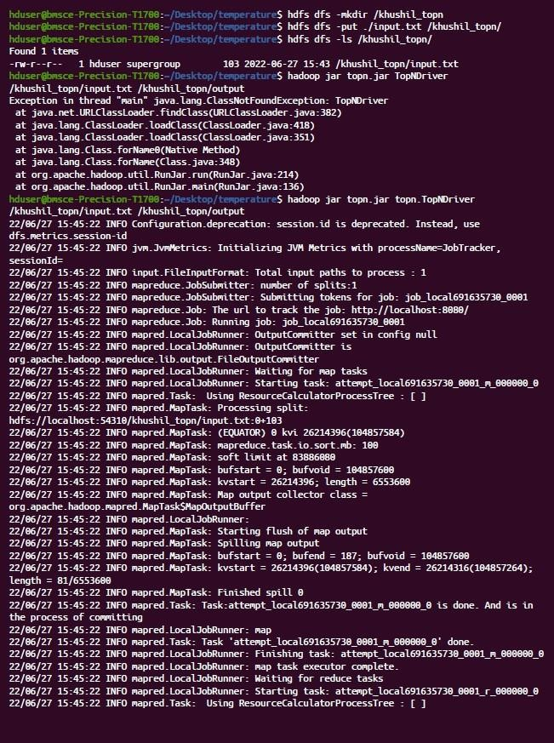 Output:

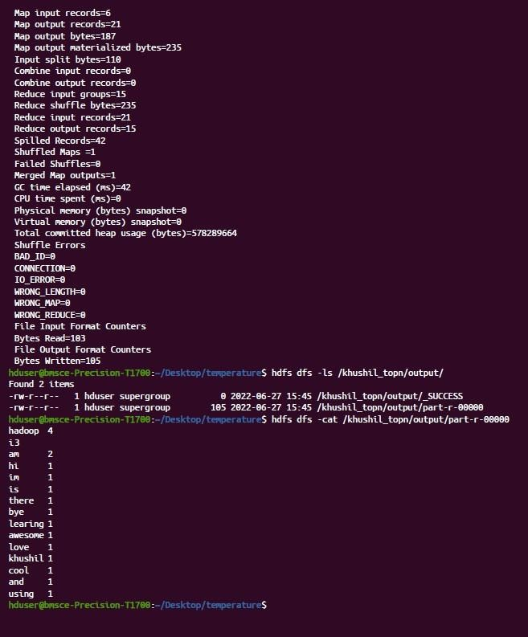

3) Average Temperature

AverageDriver **package** temp;

**import** org.apache.hadoop.fs.Path; **import** org.apache.hadoop.io.IntWritable; **import** org.apache.hadoop.io.Text; **import** org.apache.hadoop.mapreduce.Job;

**import** org.apache.hadoop.mapreduce.lib.input.FileInputFormat; **import** org.apache.hadoop.mapreduce.lib.output.FileOutputFormat;

**public class** AverageDriver { **public static void** main(String[] args) **throws** Exception { **if** (args.length != 2) {

System.err.println("Please Enter the input and output parameters");

System.exit(-1);

}

Job job = **new** Job();

job.setJarByClass(AverageDriver.**class**); job.setJobName("Max temperature");

FileInputFormat.addInputPath(job, **new** Path(args[0])); FileOutputFormat.setOutputPath(job, **new** Path(args[1])); job.setMapperClass(AverageMapper.**class**); job.setReducerClass(AverageReducer.**class**); job.setOutputKeyClass(Text.**class**); job.setOutputValueClass(IntWritable.**class**);

System.exit(job.waitForCompletion(**true**) ? 0 : 1); }

}

**AverageMapper**

**package** temp;

**import** java.io.IOException;

**import** org.apache.hadoop.io.IntWritable; **import** org.apache.hadoop.io.LongWritable; **import** org.apache.hadoop.io.Text; **import** org.apache.hadoop.mapreduce.Mapper;

**public class** AverageMapper **extends** Mapper<LongWritable, Text,

Text, IntWritable> { **public static final int** MISSING = 9999;

**public void** map(LongWritable key, Text value,

Mapper<LongWritable, Text, Text, IntWritable>.Context context) **throws** IOException, InterruptedException { **int** temperature;

String line = value.toString(); String year = line.substring(15, 19); **if** (line.charAt(87) == '+') {

temperature = Integer.parseInt(line.substring(88, 92));

} **else** { temperature = Integer.parseInt(line.substring(87, 92)); }

String quality = line.substring(92, 93);

**if** (temperature != 9999 && quality.matches("[01459]"))

context.write(**new** Text(year), **new** IntWritable(temperature));

}

}

AverageReducer **package** temp;

**import** java.io.IOException;

**import** org.apache.hadoop.io.IntWritable; **import** org.apache.hadoop.io.Text; **import** org.apache.hadoop.mapreduce.Reducer;

**public class** AverageReducer **extends** Reducer<Text, IntWritable,

Text, IntWritable> { **public void** reduce(Text key, Iterable<IntWritable> values, Reducer<Text, IntWritable, Text, IntWritable>.Context context) **throws** IOException, InterruptedException { **int** max_temp = 0; **int** count = 0;

**for** (IntWritable value : values) {

max_temp += value.get(); count++;

}

context.write(key, **new** IntWritable(max_temp / count));

}

}

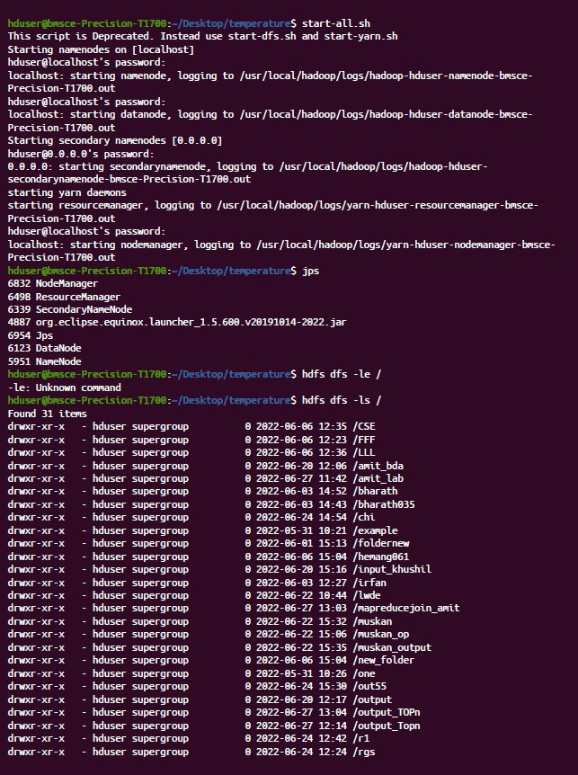 Output:

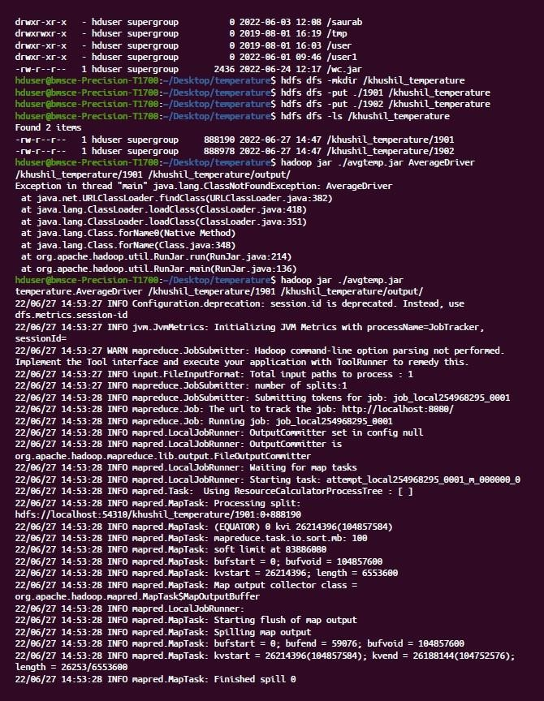

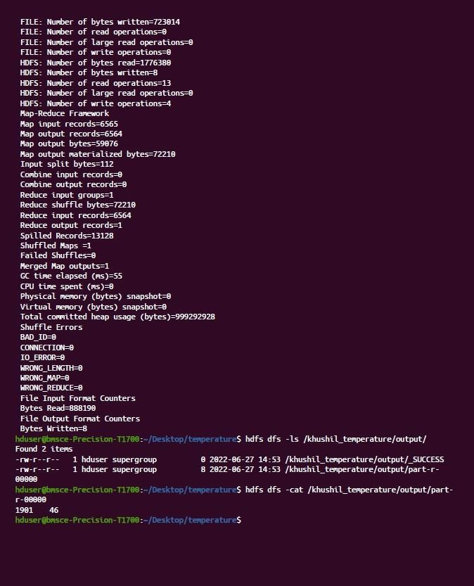

4) Join

// JoinDriver.java import org.apache.hadoop.conf.Configured; import org.apache.hadoop.fs.Path; import org.apache.hadoop.io.Text; import org.apache.hadoop.mapred.*;

import org.apache.hadoop.mapred.lib.MultipleInputs; import org.apache.hadoop.util.*;

public class JoinDriver extends Configured implements Tool {

public static class KeyPartitioner implements Partitioner<TextPair, Text> {

@Override

public void configure(JobConf job) {

}

@Override

public int getPartition(TextPair key, Text value, int numPartitions) {

return (key.getFirst().hashCode() & Integer.MAX_VALUE) % numPartitions;

}

}

@Override public int run(String[] args) throws Exception {

if (args.length != 3) {

System.out.println("Usage: <Department Emp Strength input>

<Department Name input> <output>"); return -1;

}

JobConf conf = new JobConf(getConf(), getClass());

conf.setJobName("Join 'Department Emp Strength input' with 'Department Name input'");

Path AInputPath = new Path(args[0]);

Path BInputPath = new Path(args[1]);

Path outputPath = new Path(args[2]);

MultipleInputs.addInputPath(conf, AInputPath, TextInputFormat.class,

Posts.class);

MultipleInputs.addInputPath(conf, BInputPath, TextInputFormat.class, User.class);

FileOutputFormat.setOutputPath(conf, outputPath); conf.setPartitionerClass(KeyPartitioner.class);

conf.setOutputValueGroupingComparator(TextPair.FirstComparator.class); conf.setMapOutputKeyClass(TextPair.class); conf.setReducerClass(JoinReducer.class); conf.setOutputKeyClass(Text.class);

JobClient.runJob(conf);

return 0;

}

public static void main(String[] args) throws Exception {

int exitCode = ToolRunner.run(new JoinDriver(), args); System.exit(exitCode);

}

}

// JoinReducer.java import java.io.IOException; import java.util.Iterator; import org.apache.hadoop.io.Text; import org.apache.hadoop.mapred.*;

public class JoinReducer extends MapReduceBase implements Reducer<TextPair, Text, Text, Text> {

@Override

public void reduce (TextPair key, Iterator<Text> values, OutputCollector<Text, Text> output, Reporter reporter)

throws IOException

{

Text nodeId = new Text(values.next()); while (values.hasNext()) {

Text node = values.next();

Text outValue = new Text(nodeId.toString() + "\t\t" + node.toString()); output.collect(key.getFirst(), outValue);

}

}

}

// User.java

import java.io.IOException;

import java.util.Iterator;

import org.apache.hadoop.conf.Configuration; import org.apache.hadoop.fs.FSDataInputStream; import org.apache.hadoop.fs.FSDataOutputStream; import org.apache.hadoop.fs.FileSystem; import org.apache.hadoop.fs.Path; import org.apache.hadoop.io.LongWritable; import org.apache.hadoop.io.Text; import org.apache.hadoop.mapred.*; import org.apache.hadoop.io.IntWritable;

public class User extends MapReduceBase implements Mapper<LongWritable, Text, TextPair, Text> {

@Override

public void map(LongWritable key, Text value, OutputCollector<TextPair, Text> output, Reporter reporter)

throws IOException

{

String valueString = value.toString();

String[] SingleNodeData = valueString.split("\t"); output.collect(new TextPair(SingleNodeData[0], "1"), new

Text(SingleNodeData[1]));

}

}

// Posts.java

import java.io.IOException;

import org.apache.hadoop.io.*;

import org.apache.hadoop.mapred.*;

public class Posts extends MapReduceBase implements Mapper<LongWritable, Text, TextPair, Text> {

@Override

public void map(LongWritable key, Text value, OutputCollector<TextPair, Text> output, Reporter reporter)

throws IOException

{

String valueString = value.toString(); String[] SingleNodeData = valueString.split("\t");

output.collect(new TextPair(SingleNodeData[3], "0"), new

Text(SingleNodeData[9]));

}

}

// TextPair.java

import java.io.*;

import org.apache.hadoop.io.*; public class TextPair implements WritableComparable<TextPair> {

private Text first;

private Text second;

public TextPair() {

set(new Text(), new Text());

}

public TextPair(String first, String second) {

set(new Text(first), new Text(second));

}

public TextPair(Text first, Text second) {

set(first, second);

}

public void set(Text first, Text second) { this.first = first; this.second = second;

}

public Text getFirst() {

return first;

}

public Text getSecond() {

return second;

}

@Override

public void write(DataOutput out) throws IOException {

first.write(out);

second.write(out);

}

@Override

public void readFields(DataInput in) throws IOException { first.readFields(in); second.readFields(in);

}

@Override public int hashCode() { return first.hashCode() * 163 + second.hashCode(); }

@Override

public boolean equals(Object o) { if (o instanceof TextPair) { TextPair tp = (TextPair) o;

return first.equals(tp.first) && second.equals(tp.second);

}

return false;

}

@Override

public String toString() { return first + "\t" + second;

}

@Override

public int compareTo(TextPair tp) { int cmp = first.compareTo(tp.first); if (cmp != 0) { return cmp;

}

return second.compareTo(tp.second);

}

// ^^ TextPair

// vv TextPairComparator public static class Comparator extends WritableComparator { private static final Text.Comparator TEXT_COMPARATOR = new Text.Comparator();

public Comparator() { super(TextPair.class);

}

@Override

public int compare(byte[] b1, int s1, int l1, byte[] b2, int s2, int l2) {

try { int firstL1 = WritableUtils.decodeVIntSize(b1[s1]) + readVInt(b1, s1); int firstL2 = WritableUtils.decodeVIntSize(b2[s2]) + readVInt(b2, s2); int cmp = TEXT_COMPARATOR.compare(b1, s1, firstL1, b2, s2, firstL2); if (cmp != 0) { return cmp;

}

return TEXT_COMPARATOR.compare(b1, s1 + firstL1, l1 - firstL1,

b2, s2 + firstL2, l2 - firstL2);

} catch (IOException e) { throw new IllegalArgumentException(e); }

}

}

static {

WritableComparator.define(TextPair.class, new Comparator()); }

public static class FirstComparator extends WritableComparator { private static final Text.Comparator TEXT_COMPARATOR = new Text.Comparator();

public FirstComparator() { super(TextPair.class);

}

@Override

public int compare(byte[] b1, int s1, int l1, byte[] b2, int s2, int l2) {

try { int firstL1 = WritableUtils.decodeVIntSize(b1[s1]) + readVInt(b1, s1); int firstL2 = WritableUtils.decodeVIntSize(b2[s2]) + readVInt(b2, s2); return TEXT_COMPARATOR.compare(b1, s1, firstL1, b2, s2, firstL2);

} catch (IOException e) { throw new IllegalArgumentException(e); }

}

@Override

public int compare(WritableComparable a, WritableComparable b) {

if (a instanceof TextPair && b instanceof TextPair) {

return ((TextPair) a).first.compareTo(((TextPair) b).first);

}

return super.compare(a, b);

}

}

}

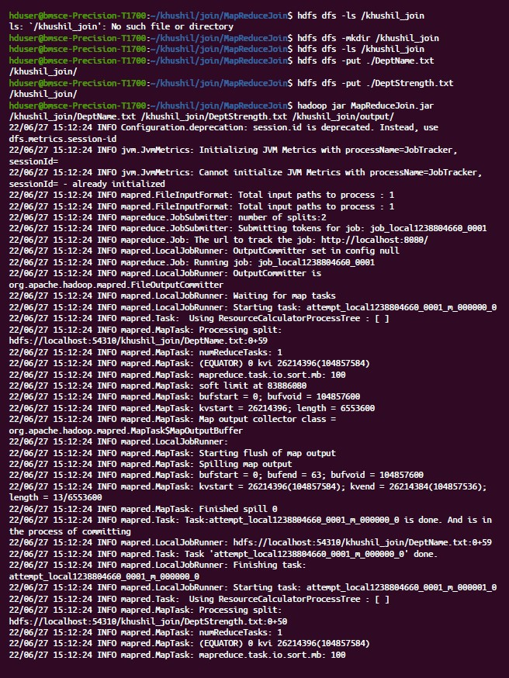Output:

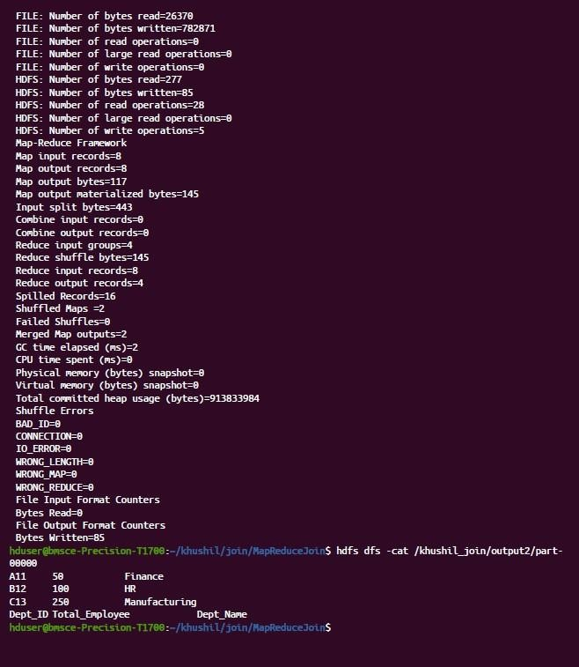

Scala

Programming:

Lab

9:

val data=sc.textFile("sparkdata.txt")

data.collect;

val

splitdata

=

data.flatMap(line

=

**>**

line.split("

"));

splitdata.collect;

val

mapdata

=

splitdata.map(word

=

**>**

(

word,1));

mapdata.collect;

val reducedata = mapdata.reduceByKey(_+_);

reducedata.collect;

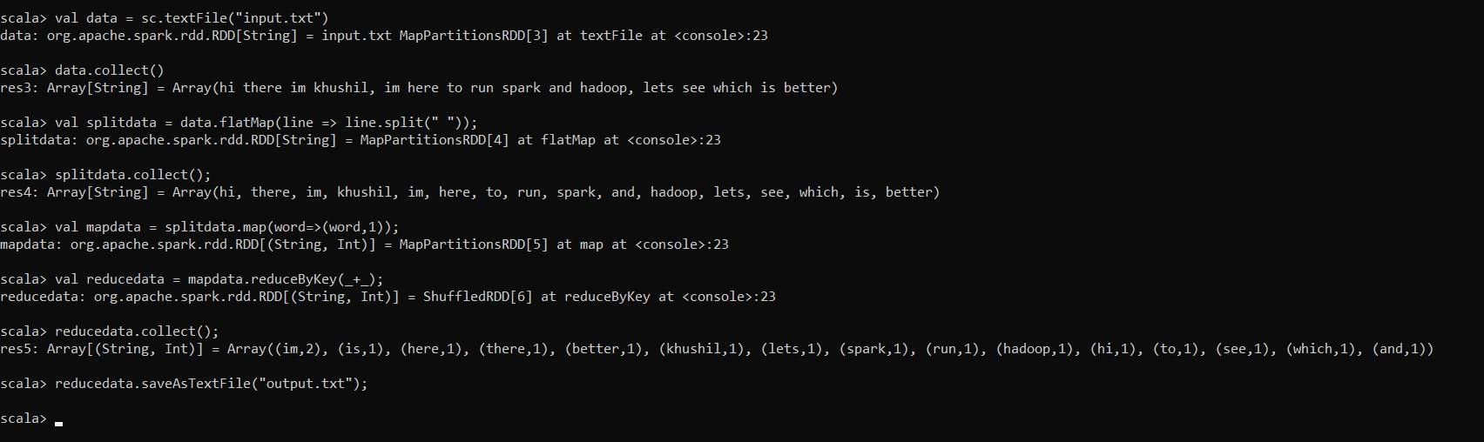

Lab 10:

val textFile = sc.textFile("/home/bhoom/Desktop/wc.txt")

val counts = textFile.flatMap(line => line.split(" ")).map(word => (word,

1)).reduceByKey(_ + _)

import scala.collection.immutable.ListMap

val sorted=ListMap(counts.collect.sortWith(_._2 > _._2):_*)// sort in

descending order based on values

println(sorted)

for((k,v)<-sorted)

{ if(v>4)

{ print(k+",") print(v) println()

}}

